**Project Development Phase**

**Project Development Delivery of Sprint 4**

|  |  |
| --- | --- |
| Team ID | PNT2022TMID50825 |
| Project name | Personal Expense Tracker Application |

**Architecture:**

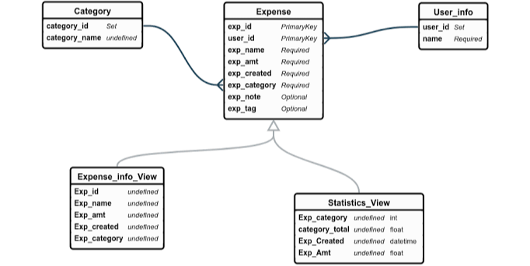

**Application features:**

* Perfect application to keep track of the expenses.
* Provides good access to expenditure monitoring.
* Handy and very easy to use.
* Efficient application to provide the service.
* Supported to most of the devices.
* Ability to keep track of the bank account information.
* Supports most of the popular languages.